1. Which of the following are graphs of functions? If the graph is that of a function, is it one-to-one?

a) b) c) d)

1. If f(x) = 4 -, find the following in simplified form:

a) f(5) b) f(9) c) f(a + 2)

d) f(-x) e) f(x²) f) [f(x)]²

g) Find the domain of f(x).

1. If f(x) =, find

a) f(3) b) f(5) c) f(a – 1)

1. Find the domain of f.
2. Determine the average rate of change for the function f(t) = t² - 2t between t = 2 and t = 5.

1. a) One-to-one function b) function c) not a function d) not a function 2 a) 1 b) 4 -  c) 4 -  d) 4 -  e) 4 -  f) 10 -  g) {x|x≥2 3. a) 2/3 b) /5 c) /(a-1) d) [-1,0)(0, inf.) 4. 5

1. a) Sketch the graph of the function f(x) = x³ (by plotting points) 5.
2. Use part (a) to graph the function g(x) = (x – 1)³ - 2.
3. a) How is the graph of y = f(x – 3) + 2 obtained from the graph of f?
4. How is the graph of y = f(-x) obtained from the graph of f?
5. a) Write the quadratic function f(x) = 2x² - 8x + 13 in vertex form. 7.

1. Sketch a graph of f to the right.
2. What is the minimum value of f?
3. Let.  
   1. Evaluate f(-2)
   2. Evaluate f(1)
   3. Sketch the graph of f to the right.

1. If f(x) = x² + 1 and , find the following and state the domain.

a) f(g(x)) b) g(x)+f(x) c) f(g(2))

d) g(f(2)) e) fg f) g(g(g(x)))

6. a) 3 right and 2 up b) reflect the graph f(x) about the y-axis 7 a) 2(x – 2)² + 5 = 0 c) f(2) = 5 8. a) -3 b) no solution

9. a)  b)  c) 2 d) 1/2 e)  f) 

1. A stone is thrown upward from the top of a building. Its height (in feet) above the ground after t seconds is given by h(t) = -16t² + 48t + 32. What maximum height does it reach?
2. Find a function that models the volume of a cube in terms of its surface area.
3. If 1800 ft of fencing is available to build five adjacent pens, as shown in the diagram to the right, express the total area of the pens as a function of x.

y

x

1. What value of x will maximize the total area for question 12?
2. Find the inverse of the function.

a) f(x) =  b) f(x) = 

10. 68 ft. high 11.  12. A = 900x – 3x² 13. 150 ft. 14. a)  b) 

1. Use the **Inverse property** to show that f and g are inverses of each other.

f(x) = 2x – 5 g(x) = 

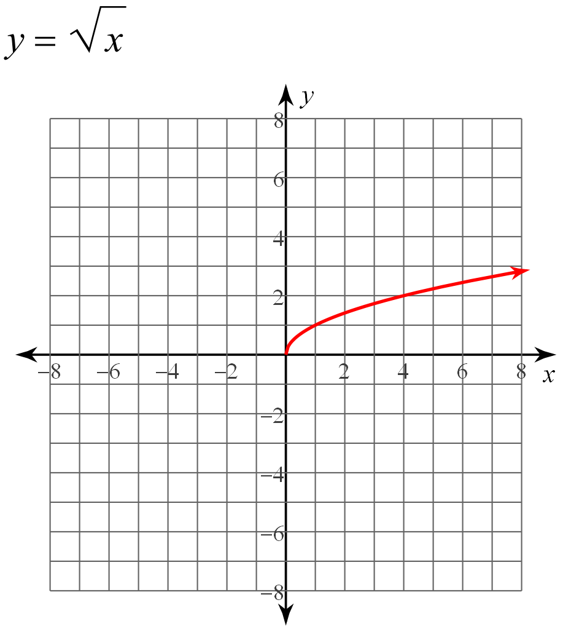

1. The graph of a function f is given on the right.
   1. Find the domain and range of f.
   2. Sketch the graph of .
   3. Find the average rate of change of f between f(0) and f(5).
2. Let f(x) =  (Use your calculator)
   1. Draw the graph of f in the appropriate viewing rectangle.
   2. Is f one-to-one?
   3. Find the local maximum and minimum values of f and the values of x at which they occur. State each answer correct to two decimal places.
   4. Use the graph to determine the range of f.
   5. Find the intervals on which f is increasing and on which f is decreasing.

15. yes they are inverses 16 a) [0, ∞) c)  17. b) No by HLT c) Max f(.18) = -2.5 Min. f(-1.6) = -27.2 and f(1.4) = -11.9

d) [-27.18, ∞) e) increasing: (-1.6, .18) and (1.4, ∞) Decreasing: (-∞, -1.61) and (.18, 1.43)